**Will-of-the-children Codebook**

Session configuration  
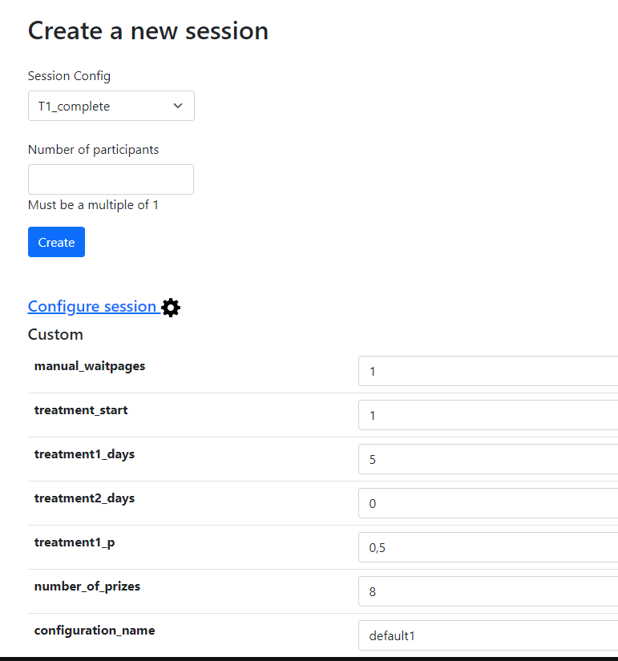  
  
manual_waitpages:  
This variable set to 1 hides the buttons of the waitpages before each part of the experiment. The only way of advancing the pages with this option enabled is by using the ”Advance slowest user” button. Set it to 0 to display the buttons. Bots can only run with this option disabled.  
  
treatment_start:  
This variable selects which treatment will be run first when the session is running multiple treatments.  
  
treatment1_days / treatment2_days:  
These variables set the number of rounds that will be ran of each treatment.  
  
Example:  
treatment_start = 2; treatment1_days = 7; treatment2_days = 3  
Will run 10 rounds in total, the first 3 rounds will be from treatment 2 and the last 7 will be from treatment 1.

treatment1_p:  
This variable can be any float number from 0 to 1 and represents the probability of the round selected for payments to be from treatment 1. The probability for treatment 2 will be [1 – treatment1_p]. The outcome of this variable is recorded at the variable ”treatment_rand”. If this random number is below ”treatment_rand” then treatment 1 is selected, treatment 2 is selected otherwise.  
  
number_of_prizes:  
This variable changes the number of options available at step 1 from 3 to 20.  
The images used for the prizes have to be available at the folder: ”will-of-the-children/_static/” with the names ”PrizeXX.png”.  
  
configuration_name:  
This variable contains the label used to build the names of the csv files where the software will look for the configurations of the parties. The names will be, if the variable is ”default1”: ”default1_treatment1.csv” and ”default1_treatment2.csv”.  
The files used to set the parties configurations have to be available at the root of the project ”will-of-the-children/”.  
The files must contain a table like the one in the example below:  
  
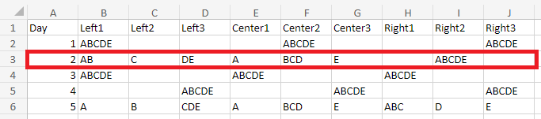  
  
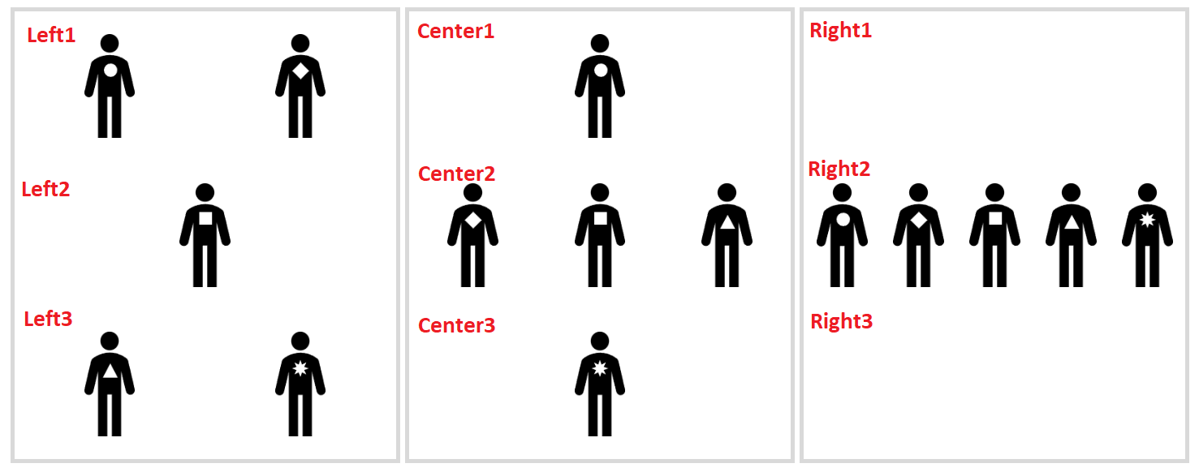

CSV Data Export

All: Participant

|  |  |  |
| --- | --- | --- |
| **Name** | **Description** | **Value** |
| id_in_session | Subject's ID during all the experiment. | 1 to N |
| code | Subject's code. |  |
| label | Not used. |  |
| _is_bot | 1 = Subject is a bot  0 = Subject is human | 0 or 1 |
| _index_in_pages | ID of the last page that the subject has visited.  0 = Subject has not started | 0 to _max_page_index |
| _max_page_index | Total number of pages. |  |
| _current_app_name | Name of the current app. |  |
| _current_page_name | Name of the current page. |  |
| time_started | Server time when the subject opened the link. |  |
| visited | 1 = Subject has started  0 = Subject has not started | 0 or 1 |
| mturk_worker_id | Not used. |  |
| mturk_assignment_id | Not used. |  |
| payoff | Number of the prize obtained. | 1 to 20 |

All: Session

|  |  |  |
| --- | --- | --- |
| **Name** | **Description** | **Value** |
| code | Code of the session. |  |
| label | Not used. |  |
| mturk_HITId | Not used. |  |
| mturk_HITGroupId | Not used. |  |
| comment | Not used. |  |
| is_demo | 1 = Session is demo (will be deleted)  0 = Session is normal | 0 or 1 |
| Config vars | | |
| real_world_currency_per_point | Not used. |  |
| participation_fee | Not used. |  |
| manual_waitpages | 0 = Waitpages have to be advanced  1 = Waitpages have buttons | 0 or 1 |
| treatment_start | 1 = Session starts with treatment 1  2 = Session starts with treatment 2 | 1 or 2 |
| treatment1_days | Number of rounds to play of treatment 1. | 1 to 30 |
| treatment2_days | Number of rounds to play of treatment 2. | 1 to 30 |
| treatment1_p | Probability that a treatment 1 round is selected for payments over a round from treatment 2. | 0 to 1 |
| number_of_prizes | Number of prizes that subjects have to order from 1 to 3 in part 1. | 3 to 20 |
| configuration_name | Prefix of the file where the experiment takes configuration of the parties in part 2. | “default1” |

step_1: Player

|  |  |  |
| --- | --- | --- |
| **Name** | **Description** | **Value** |
| id_in_group | Unique ID of the player in their group. | 1 to N |
| role | Not used. |  |
| payoff | Not used. Final payoff stored in external csv. |  |
| first_name | First name of the player |  |
| last_name | Last name of the player |  |
| email | Email of the player |  |
| ranking_1 | Prize with most value for the player. | “PrizeXX” |
| ranking_2 | Second prize with most value for the player. | “PrizeXX” |
| ranking_3 | Third prize with most value for the player. | “PrizeXX” |
| time_total | Total time used to complete step 1 in seconds. |  |
| time_in | Time of the server when step 1 was requested. |  |
| time_out | Time of the server when step 1 was completed. |  |

step_2: Player

|  |  |  |
| --- | --- | --- |
| **Name** | **Description** | **Value** |
| id_in_group | Unique ID of the player in their group. | 1 to N |
| role | Not used. |  |
| payoff | Not used. Final payoff stored in external csv. |  |
| treatment | Treatment effective this round. | 1 or 2 |
| current_day | Day loaded this round. | 1 to 30 |
| party_left1 | Avatars displayed at the top of the left party. | “ABCDE” |
| party_left2 | Avatars displayed at the center of the left party. | “ABCDE” |
| party_left3 | Avatars displayed at the bottom of the left party. | “ABCDE” |
| party_center1 | Avatars displayed at the top of the center party. | “ABCDE” |
| party_center2 | Avatars displayed at the center of the center party. | “ABCDE” |
| party_center3 | Avatars displayed at the bot of the center party. | “ABCDE” |
| party_right1 | Avatars displayed at the top of the right party. | “ABCDE” |
| party_right2 | Avatars displayed at the center of the right party. | “ABCDE” |
| party_right3 | Avatars displayed at the bot of the right party. | “ABCDE” |
| color_left | Color of the hat of the left party. | “Yellow”  “Purple”  “Orange” |
| color_center | Color of the hat of the center party. | “Yellow”  “Purple”  “Orange” |
| color_right | Color of the hat of the right party. | “Yellow”  “Purple”  “Orange” |
| preference | Party selected by the player. | “Left”  “Center”  “Right” |
| color_selected | Color of the hat of the selected party. | “Yellow”  “Purple”  “Orange” |
| time_total | Total time used to complete this round in seconds. |  |
| time_in | Time of the server when this round was requested. |  |
| time_out | Time of the server when this round was completed. |  |

feedback: Player

|  |  |  |
| --- | --- | --- |
| **Name** | **Description** | **Value** |
| id_in_group | Unique ID of the player in their group. | 1 to N |
| role | Not used |  |
| payoff | Not used. Final payoff stored in external csv |  |
| treatment | Treatment of the round selected for payment | 1 or 2 |
| id_in_group_p2 | Id of the player in step 2 | 1 to N |
| source | Other = Decision of other player was selected for payment  Self = Decision of this subject was selected for his own payment | “Other”  “Self” |
| target_id | Id of the subject that was used to determine the payment  If source is “Other” then the id of the subject –1 will be the target.  If source is “Self” the id of the subject itself is used. | 1 to N |
| target_round | Round selected for payment. | 1 to 30 |
| selected_avatar | Selected avatar of the party selected for payment.  ABCDE if round is from treatment 1 A if round is from treatment 2 and source is “Self”  BCDE if round is from treatment 2 and source is “Other” | “ABCDE” |
| selected_day | Day that was used in the selected round. | 1 to 30 |
| selected_color | Color of the hat of the party that the subject of the selected round choose. | “Yellow”  “Purple”  “Orange” |
| relevant_party | Party that the subject of the selected round choose. | “Left”  “Center”  “Right” |
| relevant_party1 | Avatars displayed at the top of the selected party. | “ABCDE” |
| relevant_party2 | Avatars displayed at the mid of the selected party. | “ABCDE” |
| relevant_party3 | Avatars displayed at the bot of the selected party. | “ABCDE” |
| player_prize1 | Prize with most value for the player. | “PrizeXX” |
| player_prize2 | Second prize with most value for the player. | “PrizeXX” |
| player_prize3 | Third prize with most value for the player. | “PrizeXX” |
| relevant_prize | Prize that the player earned. | “PrizeXX” |
| email | Email of the player entered in step 1 |  |
| treatment_rand | Value used to determine which treatment was selected after using treatment1_p. | 0 to 1 |

All: Group

|  |  |  |
| --- | --- | --- |
| **Name** | **Description** | **Value** |
| id_in_subsession | Not used |  |

All: Subsession

|  |  |  |
| --- | --- | --- |
| **Name** | **Description** | **Value** |
| round_number | Round number | 1 to 30 |
| manual_waitpages | 0 = Waitpages have to be advanced  1 = Waitpages have buttons | 0 or 1 |
| treatment_start | 1 = Session starts with treatment 1  2 = Session starts with treatment 2 | 1 or 2 |
| treatment1_days | Number of rounds to play of treatment 1 | 1 to 30 |
| treatment2_days | Number of rounds to play of treatment 2 | 1 to 30 |
| treatment1_p | Probability that a treatment 1 round is selected for payments over a round from treatment 2 | 0 to 1 |
| number_of_prizes | Number of prizes that subjects have to order from 1 to 3 in part 1 | 3 to 20 |
| number_of_days | treatment1_days + treatment2_days | 1 to 30 |
| configuration_name | Prefix of the file where the experiment takes configuration of the parties in part 2 | “default1” |
| configuration_file1 | Name of the file with configurations of the parties for treatment 1 | “default1_treatment1” |
| configuration_file2 | Name of the file with configurations of the parties for treatment 2 | “default1_treatment2” |